JOB APPLICATION TRACKING SYSTEM

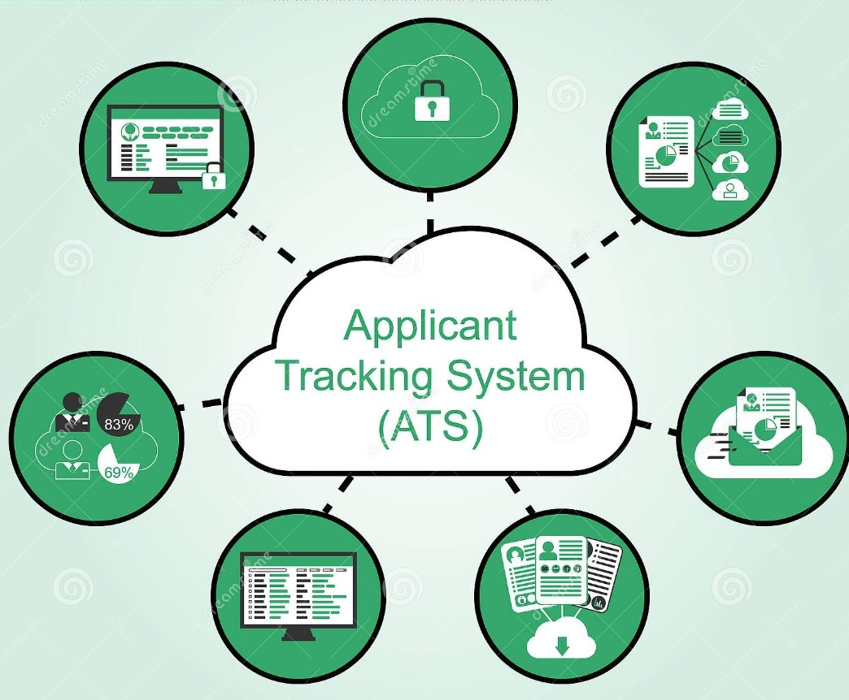

PROJECT NAME

JOB APPLICATION TRACKING SYSTEM



**TEAM ID : NM2023TMID07543**

**TEAM SIZE : 04**

**TEAM LEADER : M. SATHIYAPRIYA**

**TEAM MEMBERS : B. SHANMUGAPRIYA**

**N. SABINA**

**N. SATHANA**

**TABLE ON CONTENTS**

**INTRODUCTION …………………….**

**HOW THE APPLICANT TRACKING SYSTEM PROCESS**

**WORKS………………………………….**

**A RECRUITMENT PROCESS……………**

**SOFTWARE INCLUDE…………………**

**USE OF ZONO APPLICANT TRACKING SYSTEM……..**

**BENEFITS OF USING ZOHO RECRUITMENT ………….**

**ATS FROM EMPLOYES PERSPECTIVE ABUNDANCE APPLICANT……………………**

**CONCLUSION………………**

**INTRODUCTION**

An applicant tracking system is software that manages the recruiting and hiring process, including job postings and job applications. It organizes information about job seekers and makes it searchable. As its name implies, an ATS tracks candidates through the hiring process. It helps with interview scheduling, issues notifications and alerts, and sends automated emails to candidates and employees, such as recruiters and hiring managers.

But these systems are far more than organizers. An ATS is also used to cull applicants and recommend the top candidates. It may conduct a preliminary analysis of the applicants to find the best first for a job. It may also look for keywords or use AI-type algorithms that run a deeper analysis of the job applicant. The goal is to speed HR’s review of a job application and resumes.

**HOW THE APPLICANT TRACKING SYSTEM PROCESS WORKS**

An ATS helps an organization manage each steps of the hiring process, from writing job ad to making a job offer. This includes integrating with major job boards to streamline job postings, organize applications and allow candidates to create profiles. The ATS keeps track of all the activity the takes places around the candidate.

**THE FOLLOWING STEPS ARE TYPICAL OF A RECRUITMENT PROCES:**

* The job requisition is created and, if necessary, approved within the system.
* The job is posted in one or more locations, including internally for employees, on the organization’s website and on external jobs boards.
* Candidates apply for the position on organizations website or directly on the job board if such functionality is available. They may have to answer questions related to the position, such as their work experience.

**SOFTWARE INCLUDE :**

* + - * **Resume parsing**: This is the process of extracting data from resumes, such as contact information.
      * **Advanced search:** This enables you to filter applications by specific keywords, job titles, skills, experience, education, and more.
      * **Candidate sourcing:** This allows you to actively search for, identify and reach out to potential candidates for open positions.
      * **In build CRM Software:** Some ATS also feature CRM software to cover all your needs in one platform.
      * **Email templates:** Most ATS offer email templates to ensure that all your correspondence with candidates is consistent and professional.

**USE OF ZOHO APPLICANT TRACKING SYSTEM**

ZOHO Recruit- A simple Applicant Tracking System (ATS), which has been used in the small scale organization under study, provides an easy, collaborative and inexpensive ATS that empowers recruiters with a complete Applicant Tracking functionality in every step of staffing and recruiting process, right from sourcing to hiring candidates. It is a quite useful ATS for staffing and hiring, to acquire, screen, assess and position candidate in a short span of time.

**BENEFITS OF USING ZOHO RECRUIT (ONLINE ATS)**

1. Gives 360 -degree view of the clients, contacts, candidates and requisitions.

2. Automates the recruitment process.

3. Provides solution for both staffing agencies and corporate HR’s.

4. Gives value to the time and handles the entire recruiting process.

5. Helps to acquire right talent faster than ever.

6. Manage our clients, contacts, candidates in a single central database.

7. Improves the hiring efficiency of the business.

8. Simple and best ATS to make the best decisions.

9. Gives a visual indication of recruitment tracking.

10. Customize to match the user organization ’s needs.

11. value for money compared to other ATS.

12. No more download - Zoho Recruit is a ATS.

13. Web-based ATS that keep everyone updated on the progress.

**FEATURES**

Candidate Sourcing - Zoho Recruit- ATS, helps the user company to gather resume from different sources. The company can reach many candidates

and filter them based on its needs. This improves the quality of company’s

resume database. Resume Parsing- Extract multiple resume from document,

email attachments, folders, job portals, social sites, Google search results etc

get the candidate details along with the original resume attached into Recruitment Resume parser – Extra multiple resumes from documents, email attachments ,folders.

Reduces time for recruitment administration and hiring. Streamline the entire recruitment process and ensure best practice. Effective Management of travel expenses, back ground checks other miscellaneous recruitment related activities. Increase the Quality of Hire. Improves communication internally and externally and internal mobility within an organization.

Facilities better man power planning and budgeting. Creates a strong data base for the future. Promotes the brand of employer and marketing through job postings .

Crystallize organization sourcing strategies by identification the areas yielding best results from research efforts and the data support. Critical in management of an internal or external recruitment staff.

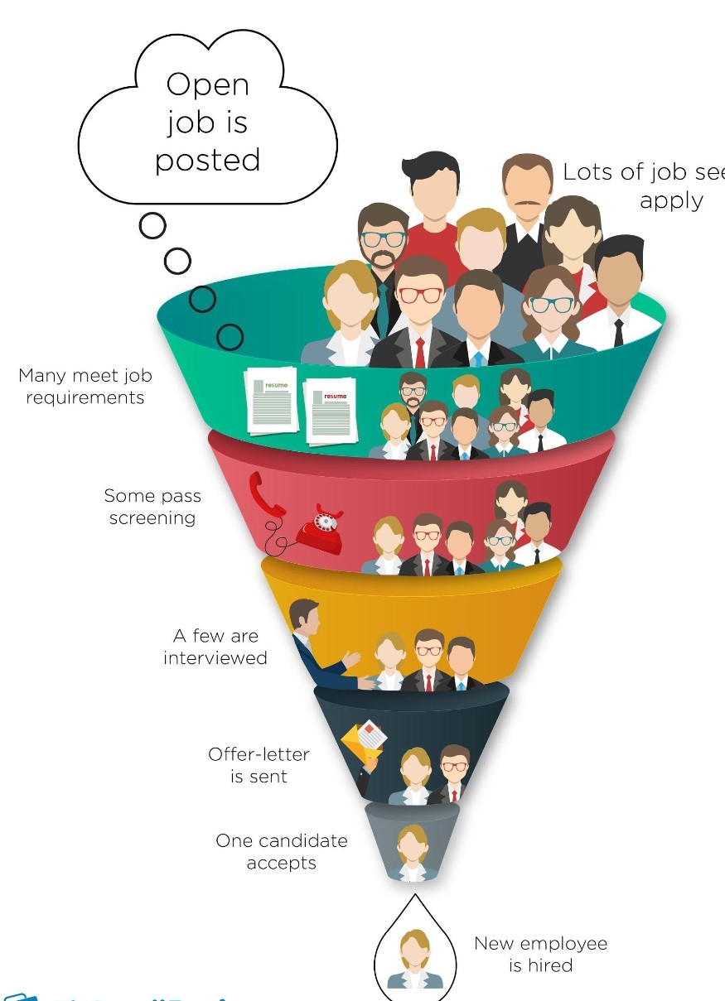

**ASSESSMENT OF ATS FROM JOB APPLICANT PERSPECTIVE**

Many jobseekers attest that looking for a job online lacks a personal touch. Jobs seekers want to be able to talk to someone via phone or face should they are interested in applying for. Job seekers claim employers are so inaccessible and display very little or no human intersection. This is has been so far the biggest complaint. Outdated job postings It s the biggest drawback of online recruitment that job applicants detest. May applicants claim they have applied for what appeared to be a current job posting, only to find out weeks later that the position had been filled a month ago? How devastating this is for individuals who are hoping to land and interview with a prospective employer . Had the aspirant known the position was filled she/he would have never applied for it. This is simply a worker.

**CONCLUSION**

To sum up and conclude, applicant tracking system helps the HR department to meet the challenge of current time. Many companies have seen a need to transform the way Human Resource operation are performed in order to keep up with new technology and increasing number of employees. The human intelligence is closely related with the human experience and decision making skills which is strongly backed by information. Now day in every field of human working right information is considered as the most important resource of good decision making.

The end result of the recruitment process is essential a pool of applicants. Next to recruitment the logical step in the HR process is the selection of qualifies and complement people. As such , this process concentrates of differentiating between applicants in order to organization recruitments ultimately fulfilling the goal of the organization.

C:\Program Files (x86)\Microsoft Office\MEDIA\CAGCAT10\j0195384.wmf

**\*\*\*\*\*\*\*\*\*\*\***